Ant Financial – an introduction
Who We Are
Ant Financial Services Group is dedicated to using technology to provide inclusive financial services to individuals as well as small and micro enterprises. We believe financial services should be simple, low-cost and accessible to the many, not the few. And our technologies, such as cloud computing and Big Data analytics, make us uniquely placed to achieve this. Ant Financial is building an open ecosystem, enabling traditional financial institutions to provide services in a more efficient way.
Our name embodies the strength that a small team can harness through teamwork and commitment to a common goal, as well as our mission of bringing small but beautiful changes to the world.
Ant Financial is an independently managed and operated business, and a related company of Alibaba Group.

What We Do
We have developed a wide range of products and services, covering payments, loans, insurance, and wealth management, focusing on the financial needs of small businesses and individuals.
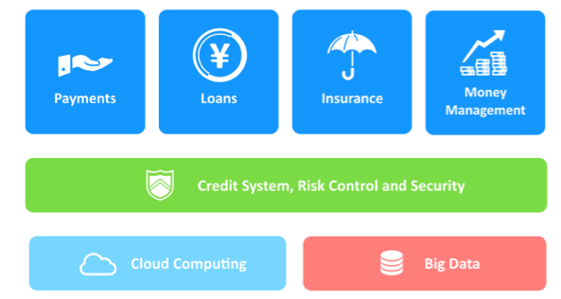
Innovative technology and extensive data analysis underpin everything we do. The cloud and Big Data power our rigorous credit, security and risk control processes, and allow us to tailor our products to customers’ individual needs and operate in the safest, most efficient and cost-effective manner.

Our History
In 2004, Alibaba established Alipay to address the issue of trust between buyers and sellers online. Buyers were unwilling to make payments before receiving and inspecting their purchases, and sellers were unwilling to ship the products until they were assured that payment was forthcoming. The lack of trust posed a major challenge for the development of online commerce in China. Alipay introduced its escrow service as a solution to this problem.

Alipay became Small and Micro Financial Services Company in 2011. Small and Micro Financial Services Company was rebranded as Ant Financial Services Group in October 2014. Alibaba does not have any ownership interest in Alipay. The two companies are related companies.

Our Products & Services
Ant Financial has developed a range of products meeting the diverse financial services needs of our customers. With all our products, our aim is to simplify and democratize the process for our customers, giving access to financial services to the many, not the few.
- Alipay: Operated by Ant Financial Services Group, Alipay is the world’s leading mobile and online paymentplatform. Launched in 2004, Alipay currently has over 450 million active users and more than 200 domestic financial institution partners. During the 2015 11.11 Global Shopping Festival, China’s equivalent of Cyber Monday, Alipay processed RMB 91.3 billion worth of transactions from Alibaba’s marketplaces and its peak transaction handling volume reached 85,900 per second. Alipay has evolved from a digital wallet to a lifestyle enabler. Users can hail a taxi, book a hotel, buy movie tickets, pay utility bills, make doctors’ appointments or transfer money to each other directly from various modules within the app and purchase wealth management products such as Yu’e Bao. In addition to online payments, Alipay is expanding to in-store offline payments both inside and outside of China. Over 2,000,000 brick-and-mortar merchants now accept Alipay as a payment method across China. As of June 2016, Alipay was supported in 70 overseas markets, with in-store payments covering more than 80,000 retail stores, and tax reimbursement via Alipay is supported in 24 countries and regions, including South Korea, Germany and France. Alipay works with over 40 overseas financial institutions and payment solution providers to enable cross-border payments for Chinese travelling overseas and overseas customers who purchase products from Chinese e-commerce sites. Alipay supports the settlement of 18 currencies.
- Ant Fortune: A comprehensive wealth management app that allows users to manage their finances in one place, Ant Fortune was launched in August 2015. It offers Yu’e Bao, Zhao Cai Bao and other wealth management products, as well as allowing users to check stock movements in-app.
  - Yu’e Bao: Yu’e Bao is an online wealth management product that offers users higher returns on their current account balance, no matter how tiny their deposit. Jointly launched with China’s Tianhong Asset Management in 2013, Yu’e Bao is the world’s fourth-largest money market fund and the largest in China by volume. It currently has more than RMB 800 billion in assets under management and 300 million users as of July 2016.
- Koubei: Koubei is a joint venture established in June 2015 by Alibaba Group and Ant Financial Services Group, each of which invested RMB 3 billion as well as user traffic diverted from other synergetic products and services such as Alipay. Koubei allows users to look for local merchants, place orders, conduct payments and write reviews. It has a first-level entry point on the Taobao and Alipay apps – two of China’s most popular apps.
- MYbank and Ant Micro Loan: MYbank is a private online bank established on June 25, 2015. It is the first bank to run ‘on the cloud’. Prior to the establishment of MYbank, Ant Micro Loan offered small and micro loans to small and micro enterprises. As of June 2016, Ant Micro Loan and MYbank had provided micro loans to over 4.11 million small and micro enterprises and entrepreneurs totaling over RMB 740.1 billion.
- Zhima Credit: Based on Big Data technology, Zhima Credit is an independent organization within Ant Financial offering credit filing and scoring services for individuals, and plans to expand its services to cover enterprises. It was among the first institutions in China to receive an individual credit services license. Zhima Credit is widely used by consumer finance companies, travel agents, hotels, vehicle leasing companies and even online dating sites. Users with a higher Zhima Credit score can book a hotel or hire a public bicycle without a deposit. Building a reliable credit scoring system is a central part of Ant Financial’s overall strategy, as credit is the basis for various financial products such as loans and insurance.
- Ant Check Later: Ant Check Later grants consumer credit for individual users to shop with interest-free loans and in installments. It extends credit lines based on a series of indices such as users’ consumption frequency and payment habits. Users can shop with their Ant Check Later credit at more than 40 online shopping platforms, including Tmall, Taobao and Amazon.com, and defer repayment until the following month.

