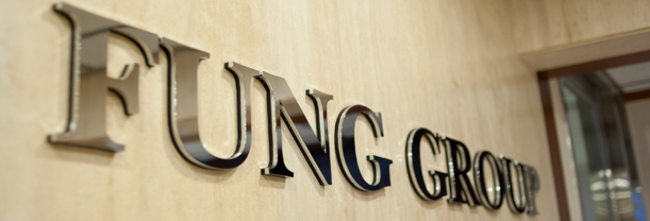
Fung Group
Fung Holdings (1937) Limited, a privately-held business entity headquartered in Hong Kong, is the major shareholder of the Fung Group of companies, whose core businesses are engaged in Trading, Logistics, Distribution and Retailing.
Li & Fung Limited (SEHK: 00494) is the leading consumer goods design, development, sourcing and logistics company for major retailers and brands around the world. It specialises in responsibly managing supply chains of high-volume, time-sensitive goods, providing sophisticated one-stop-shop solutions to meet customers' specific needs. The company's end-to-end logistics solutions span the time a product leaves a factory to when it reaches the hands of the consumer.
Global Brands Group Holding Limited (SEHK: 00787) is one of the world's leading companies for branded apparel, footwear, fashion accessories and related life-style products. It designs, develops, markets and sells products under a diverse array of controlled and licensed brands and a wide range of product categories. Its customers primarily are retailers, from department stores to specialty retailers and e-commerce channels, in the Americas, Europe and Asia.
Fung Retailing Limited operates the Group's fourth core business of retailing with two publicly-listed entities: convenience stores and bakeries through Convenience Retail Asia Limited (SEHK: 00831), and high-end to luxury menswear through Trinity Limited (SEHK: 00891), plus the following privately-held retail businesses: Branded Lifestyle Holdings Limited, operator of a retail network of middle-zone apparel and accessories in Asia; Fung Kids (Holdings) Limited, focusing on children's apparel, footwear and accessories; Toys"R"Us (Asia), a joint-venture operating the toys and children product specialty chain store Toys"R"Us in Asia; Suhyang Networks, a retailer of baby and children apparel in Korea, and UCCAL Fashion Group, specialising in prestigious lifestyle brands on the Chinese Mainland.
The Fung Group employs 45,100 men and women across 40 economies worldwide, with total revenue of over US$24.8 billion as of December 2015.

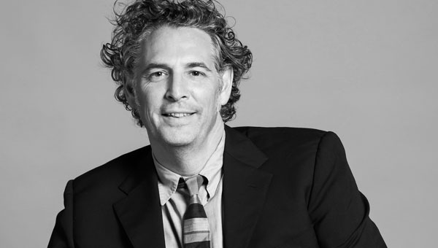

Richard Kelly Chief Catalyst, Fung Academy
​Richard Kelly is part of Fung (1937) Management and is focused on new value creation and building innovation across the group. Most recently, Richard was the Managing Director of IDEO Asia Pacific. Based in Shanghai, his role was to lead clients to realise new opportunities and build innovation capabilities through design. Clients included Coke, Samsung, TCL, VF Corp, Singapore government. Before moving to Shanghai, Richard joined IDEO London in 2006, and was responsible for the service practice and leading clients including, Nestlé, T-Mobile, IKEA, and Alpargatas. Before joining IDEO, Richard was at Levi’s Strauss & Company for 9 yrs and ran his own brand consulting business in London and San Francisco.
Richard speaks and comments regularly on innovation and design issues and has spoken at WEF, China Entrepreneur Summit, BOAO Asia Forum and CleanTech Forum in China, Skoll World Forum and appeared in China Entrepreneur magazine, Business Watch, 21St Century Business Review and on sina.com

