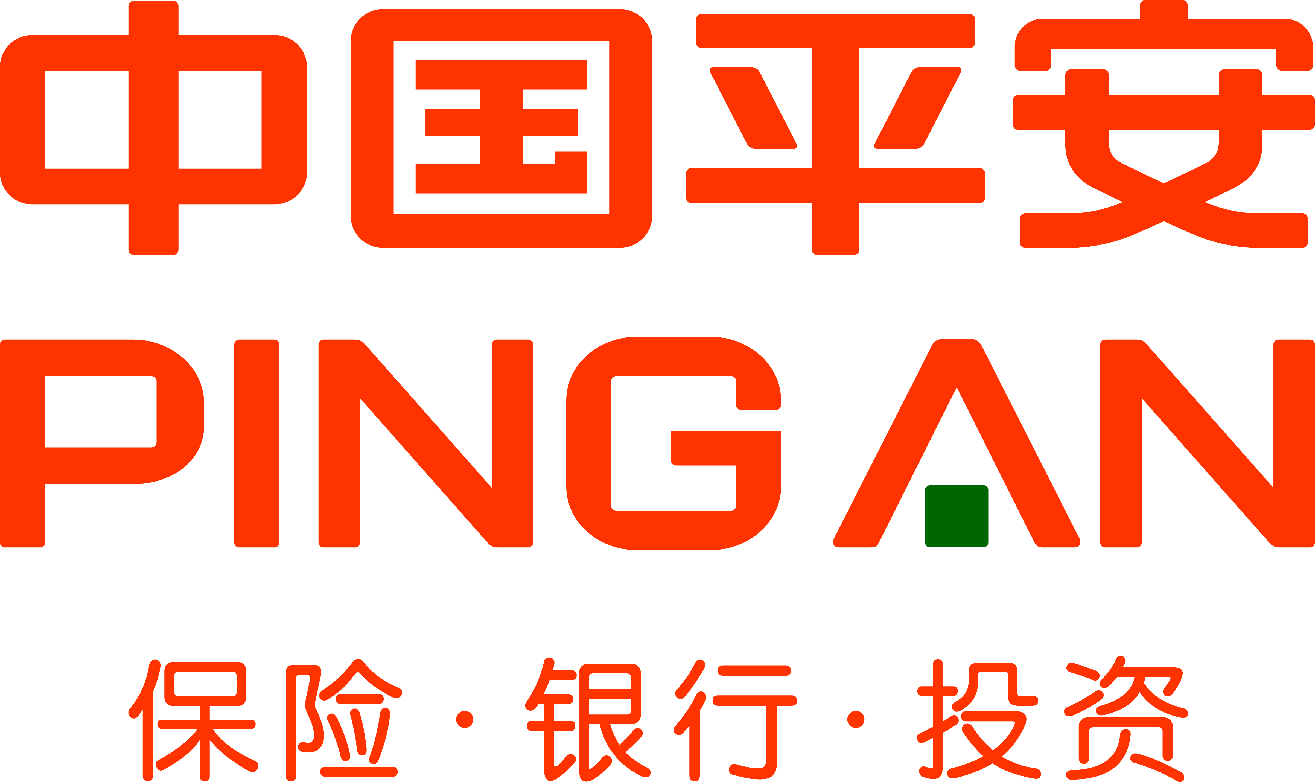 | Ping An Insurance (Group) Company of China, Ltd. was established in Shekou, Shenzhen in 1988. The Group is the first insurance company in China to adopt a shareholding structure. It has developed into a personal financial services group with three core businesses of insurance, banking and investment, enjoying parallel growth of its core and internet finance businesses. It strives to become a world-leading personal financial service provider under the philosophy of "technology-driven financial services for better life", has adopted the models of "integrated finance + the internet" and "the internet + integrated finance", focuses on "big financial assets" and "big health care", pursues growth in insurance, banking, asset management, and internet finance, provides customers with excellent experience of "expertise makes life easier", has achieved sustainable growth in profits.
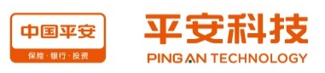 | Founded in 2008, Ping An Tech is a wholly owned subsidiary of Ping An Insurance (Group) Company of China, Ltd., a Global Fortune 500 company, and the only provider of IT services incl. IT planning, development and operational services for the Group company and its subsidiaries. Ping An Tech is also the high-tech core of Ping An Group. Along with Ping An Group’s development, Ping An Tech has accumulated profound experience in “tech + internet + finance” as the innovation incubator and main builder of the Group’s internet finance business.
  Ericson Chan  Head of Ping An Technology at PING AN GROUP | Determine to drive performance through digital solutions, service & product differentiation, and operational productivity. Passionate about all aspects of Customer Experience and anything on the online world. A true believer in simplicity and efficiency. A financial services professional and leader with proven track record across online business, innovation, technology, operations, sourcing, payments, alliances, regulatory compliance and risk governance. Dynamic management approach with broad range of functional experience across Asia and in the U.S
  Jon-Tzen Ng  Head, Strategy & Design at Ping An Technology | Jon-Tzen Ng is currently the Head, Strategy & Design at Ping An Technology and leads the General Manager’s Office. His responsibilities include strategy, user experience research and design, and brand. He was previously the Executive Director and Head of Digital & Innovation at Standard Chartered Bank and a member of the Advisory Board for the Supercharger Fintech accelerator programme. He is an advocate of the use of technology in transforming financial services and enabling work.

